Afr-Dogon-Kanaga Mask-Passport 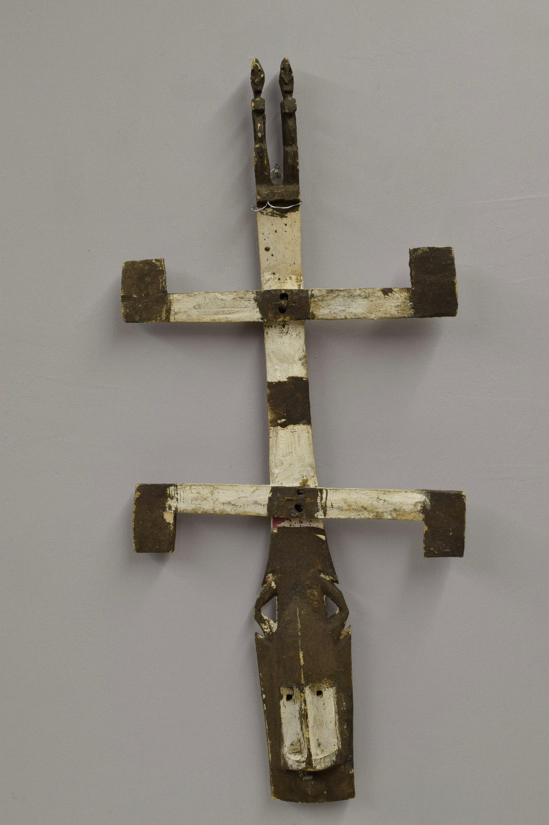 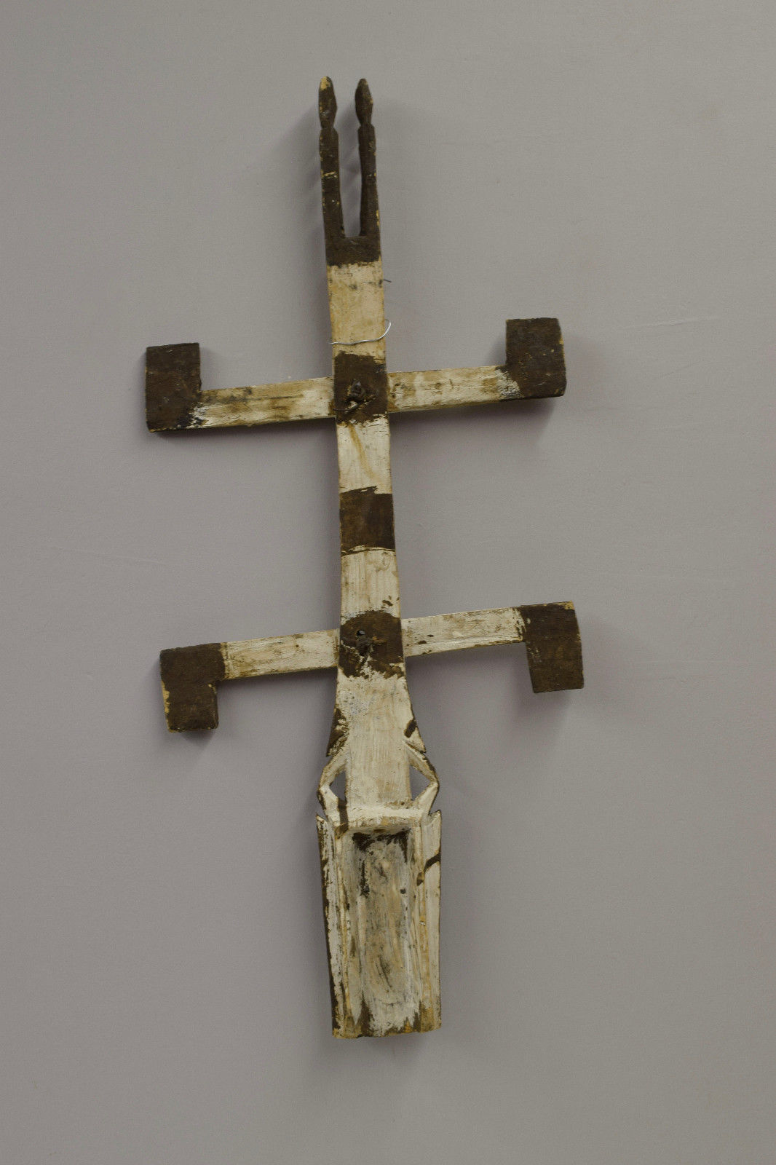

This Vintage Miniature African Dogon Kanaga Mask comes from the Tribal People of Mali. The act of carving Kanaga masks holds as much spiritual significance as the rituals in which the masks are worn. A Dogon Kanaga Mask offers a rare look at the Dogon’s highly secretive methods of mask making. Although these ceremonies are now frequently performed for the public, the sacred meaning of the Kanaga is retained by the Dogon villagers who fear, respect, and depend on the power of the mask. The Kanaga consists of a face mask with a long center post jutting up from the top. The post is crossed left to right by two short bars. The cross bars each have two smaller wooden slats referred to as arms. The lower bar has two arms pointing downwards (symbolizing man and earth) while the top bar features two arms pointing upwards (symbolizing the sky and heavens). Dogon dancers perform with Kanaga masks at 'Dama' ceremonies which honor and commemorate the dead. Miniature masks, too small to be worn, replicate the forms of masks worn in performances. Like their larger counterparts they are powerful charms, filled with spirit, with potential for good or evil. But while the full-sized masks are made for display in public ceremonies, the passport masks are not performed and are usually hidden from prying eyes. They may be kept in the compound or on a personal shrine. They are carried about the person when traveling; hence the term ‘passport’ mask.